

|  |  |
| --- | --- |
| **1** | **47** |
| **2** | **33** |
| **3** | **20** |
| **Total** | **100** |

**MARKING GUIDE**

BIOLOGY (Practical)

**Paper 3**

1. You are provided with specimen **T** which is freshly killed.
2. (i) Stretch the left hind limb of the specimen. Carefully stripe off the

skin of the limb to expose the features of the ventral side. Draw and label. (10 marks)

***T. toad***

***A drawing of the ventral features of the left hind limb when the skin is removed of specimen T.***

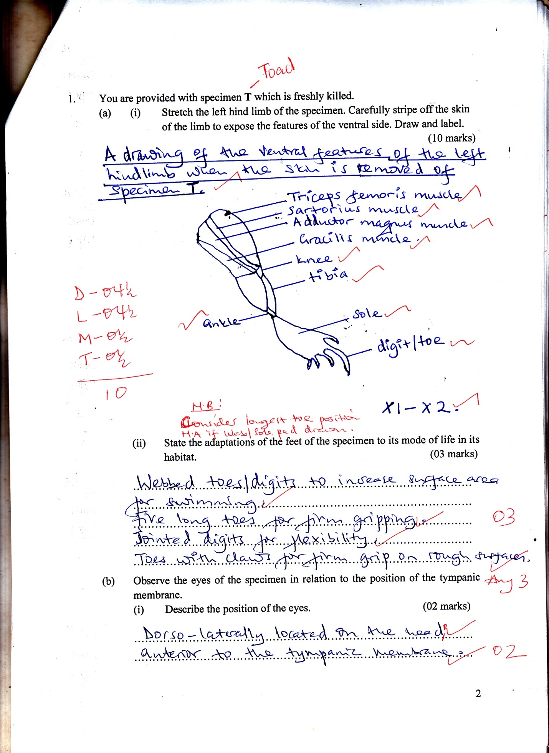

*X1 – x 2*

*NB: Consider longest toe position N.A if web / sole pad drawn*

(ii) State the adaptations of the feet of the specimen to its mode of life in its habitat.

* *Webbed toes / digits to increase surface area for swimming****;***
* *Five toes of different length on the ground for firm gripping* ***;***
* *Jointed digits for flexibility****;***
* *Toes with curved claws for firm grip on rough surfaces****;*** *(any 3)*

1. Observe the eyes of the specimen in relation to the position of the tympanic membrane.
2. Describe the position of the eyes. (02 marks)

*Dorso – laterally located on the head; anterior to the tympanic membrane****;***

1. State the significance of the structure and position of the eyes to the life of the specimen. (03 marks)

*The eyes are large****;*** *round****;*** *protruding****;*** *and dorso – laterally located on the head****;*** *anterior to each tympanic membrane to provide a wide field to the animal****;*** */ to see even when submerged; in water.*

1. Dissect specimen **T** to display;
2. The route of blood flow from the right side of the head and right fore limb to the heart.
3. Blood vessels that supply nutrients and oxygen to the parts of the alimentary canal anterior to the ileum including those of urinogenital organs situated on the left side of the abdominal cavity.

With undisplaced heart, draw and label your dissection on the same drawing. (29 marks)

***A drawing showing blood vessels that drain the right side of the head and right fore limb to the heart and those that supply nutrients and oxygen to the alimentary canal structures anterior to the ileum, with those of urinogential organs of the left side of abdominal cavity of specimen T, the heart un displaced.***

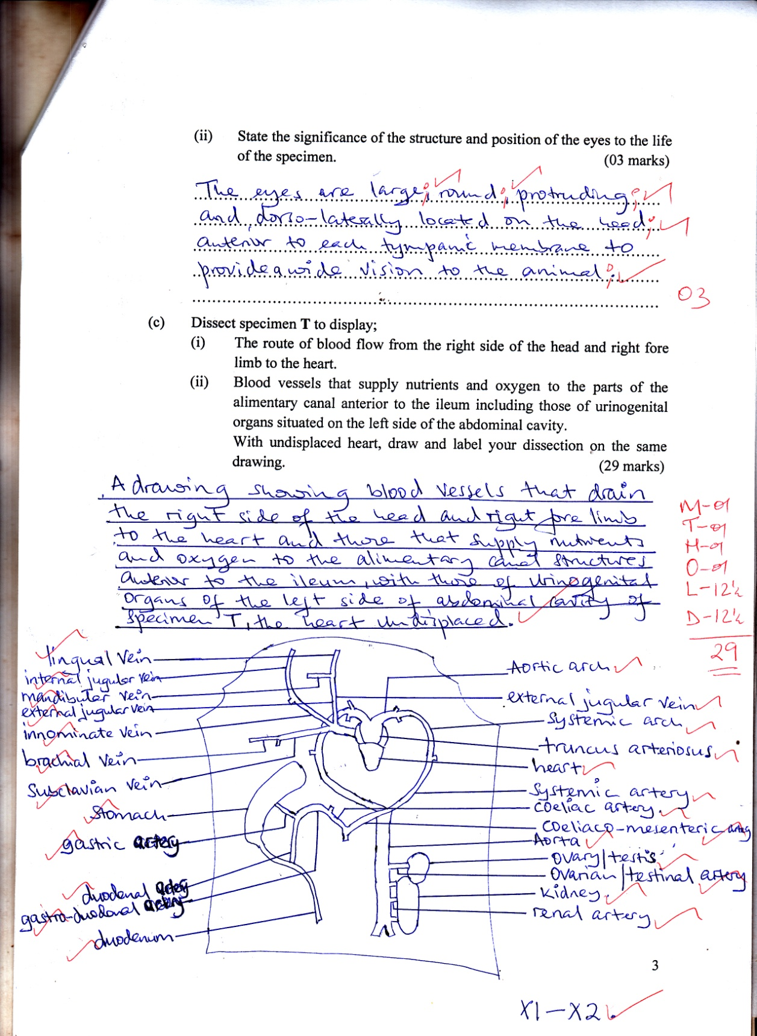

*M – 01*

*T – 01*

*N – 01*

*O – 01*

*L – 12 ½*

*D – 12 ½*

*29 marks*

X1 - X2

1. You are provided with specimen **S** which is a plant organ, and sucrose solutions **A, B, C, D, E**  of concentrations **0.5M, 0.25M, 0.15M, 0.05M, 0.00M** respectively.

Using a cork borer of diameter 0.5cm, obtain five cylinders of length 3cm each from specimen **S**. Place one cylinder in each solution and wait for **1 hour**. After this period, remove the cylinders from the solutions.

1. (i) Measure the final lengths of the cylinders and record your results in the

table below. (06 marks)

|  |  |  |  |
| --- | --- | --- | --- |
| **Solution where cylinder was placed** | **Final length of cylinder /cm** | **Initial length of cylinder /cm** | **Change in length of cylinder /cm** |
| A - 2.4 – 2.6  B - 2.9 - 3.1  C - 3.0 - 3.2  D - 3.1 - 3.3  E - 3.4 - 3.6 | 2.5  3.0  3.1  3.2  3.5 | 3.0  3.0  3.0  3.0  3.0 | -0.5  0.0  +0.1  +0.2  +0.5 |

01 m for acc

(ii) Plot a graph of the variation in change in length of cylinders against the concentrations of the sucrose solutions provided. (05 marks)

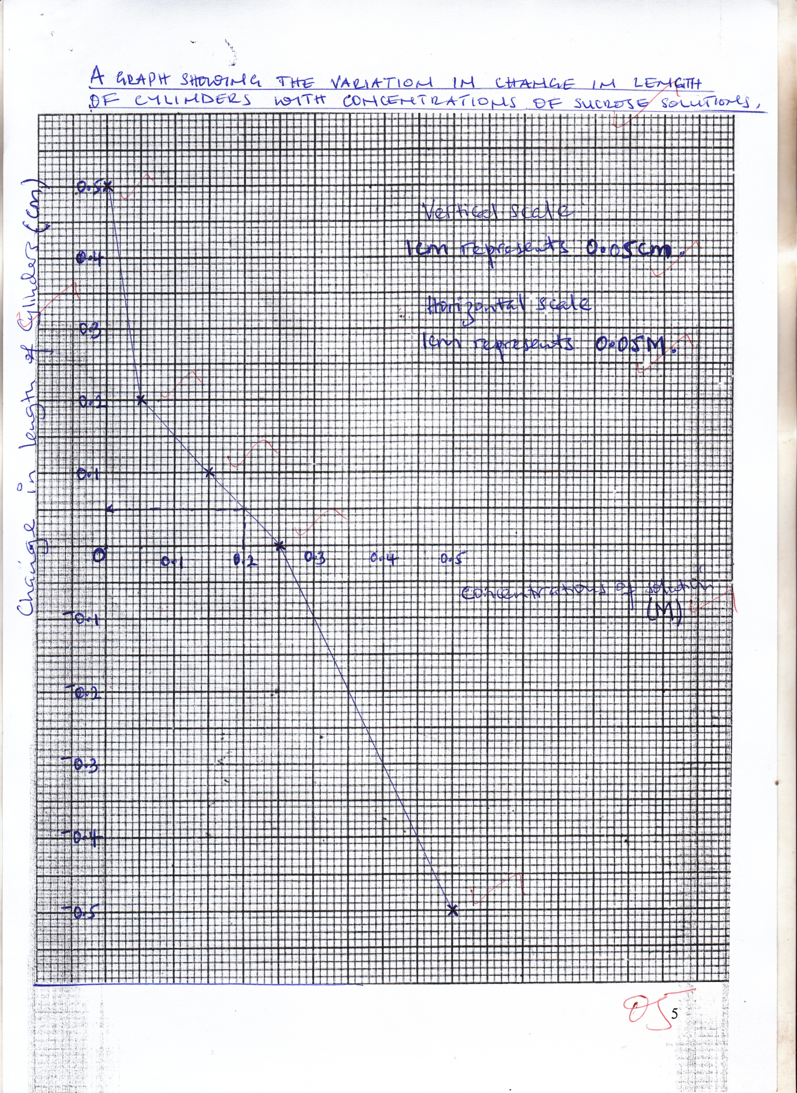

**A graph showing the variation in change in length of cylinders with concentrations of sucrose solutions**

1. Comment on the graph plotted in (ii) above. (05 marks)

* *Change in length decreases / becomes less positive with increase in sucrose concentration from 0 to 0.25M****;***
* *Change in length increases / becomes more negative with further increase in sucrose concentration above 0.25M*
* *No change in length at 0.25M sucrose concentration****;***
* *Beyond 0.25M concentration length of cylinders decreases****;***
* *Below 0.25M concentration length of cylinders increases****;***

1. (i) Using the graph above, determine the final length of a cylinder that

would be placed in 0.2M sucrose solution in the same experiment. (show your working). (03 marks)

*From the graph 0.2M solution produces +0.05cm change in length****;***

*Final length = change in length + Initial length*

*= 0.05 + 3.0* ***;***

*Therefore final length = 3.05cm* ***;***

(ii) Explain your answer in b(i) above. (04 marks)

*0.2M sucrose solution is less concentrated than the cell sap of the tissue / cylinder****;*** *by osmosis****;*** *water enters the cylinder and its cells become turgid****;*** *and causes the cylinder to swell****;***

1. Explain the texture and nature of the cylinders placed in the following solutions after 1 hour.
2. Solution **A.** (05 marks)

*Cylinder is smooth****;*** *soft****;*** *and flexible****;*** *since it was placed in solution A with which is more concentrated than its cell sap****;*** *therefore****;*** *osmotically it lost water to solution A****;*** *leaving its cells plamolysed / flaccid and shrunk****;*** *any 2 for nature*

1. Solution **E** (05 marks)

*Cylinder is rough****;*** *hard****;*** *and rigid****;*** *since it was placed in less concentrated solution than its cell sap****;*** *thus absorbed water from the solution by osmosis****;*** *its cells expanding to turgidity****;*** *(any 2)*

1. You are provided with specimens **P, Q** and **R** which are plant parts.
2. (i) Describe specimen **P** (04 marks)

* *Main axis with lateral branches of variable length, reducing towards apex****;*** *some attached alternately and others oppositely on main axis****;***
* *On each lateral branch are numerous spikes bearing several spikelets attached alternately****;*** *both main axis and lateral axis terminate into individual or double spikelet’s (flowers)* ***;***

*Accept ; tapering;*

***Inflorescences;***

*P – Guinea grass*

*Q – Bidens*

*R – Banana*

(ii) Remove a floret from specimen **P** and examine it fully. Draw but label only the structures that are directly involved in reproduction.

(04 marks)

*A drawing of a floret / spikelet of specimen* ***P*** *(****allow either way****)*

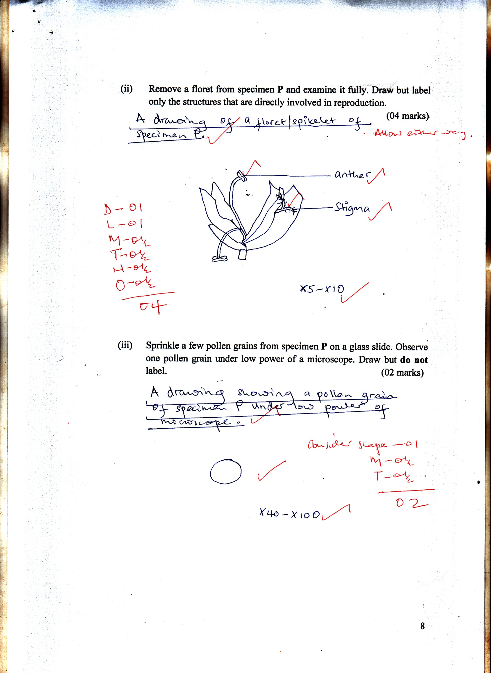

*(X5, X8, X10, X15)*

1. Sprinkle a few pollen grains from specimen **P** on a glass slide. Observe one pollen grain under low power of a microscope. Draw but **do not** label. (02 marks)

***A drawing showing a pollen grain of specimen P under low power of microscope.***

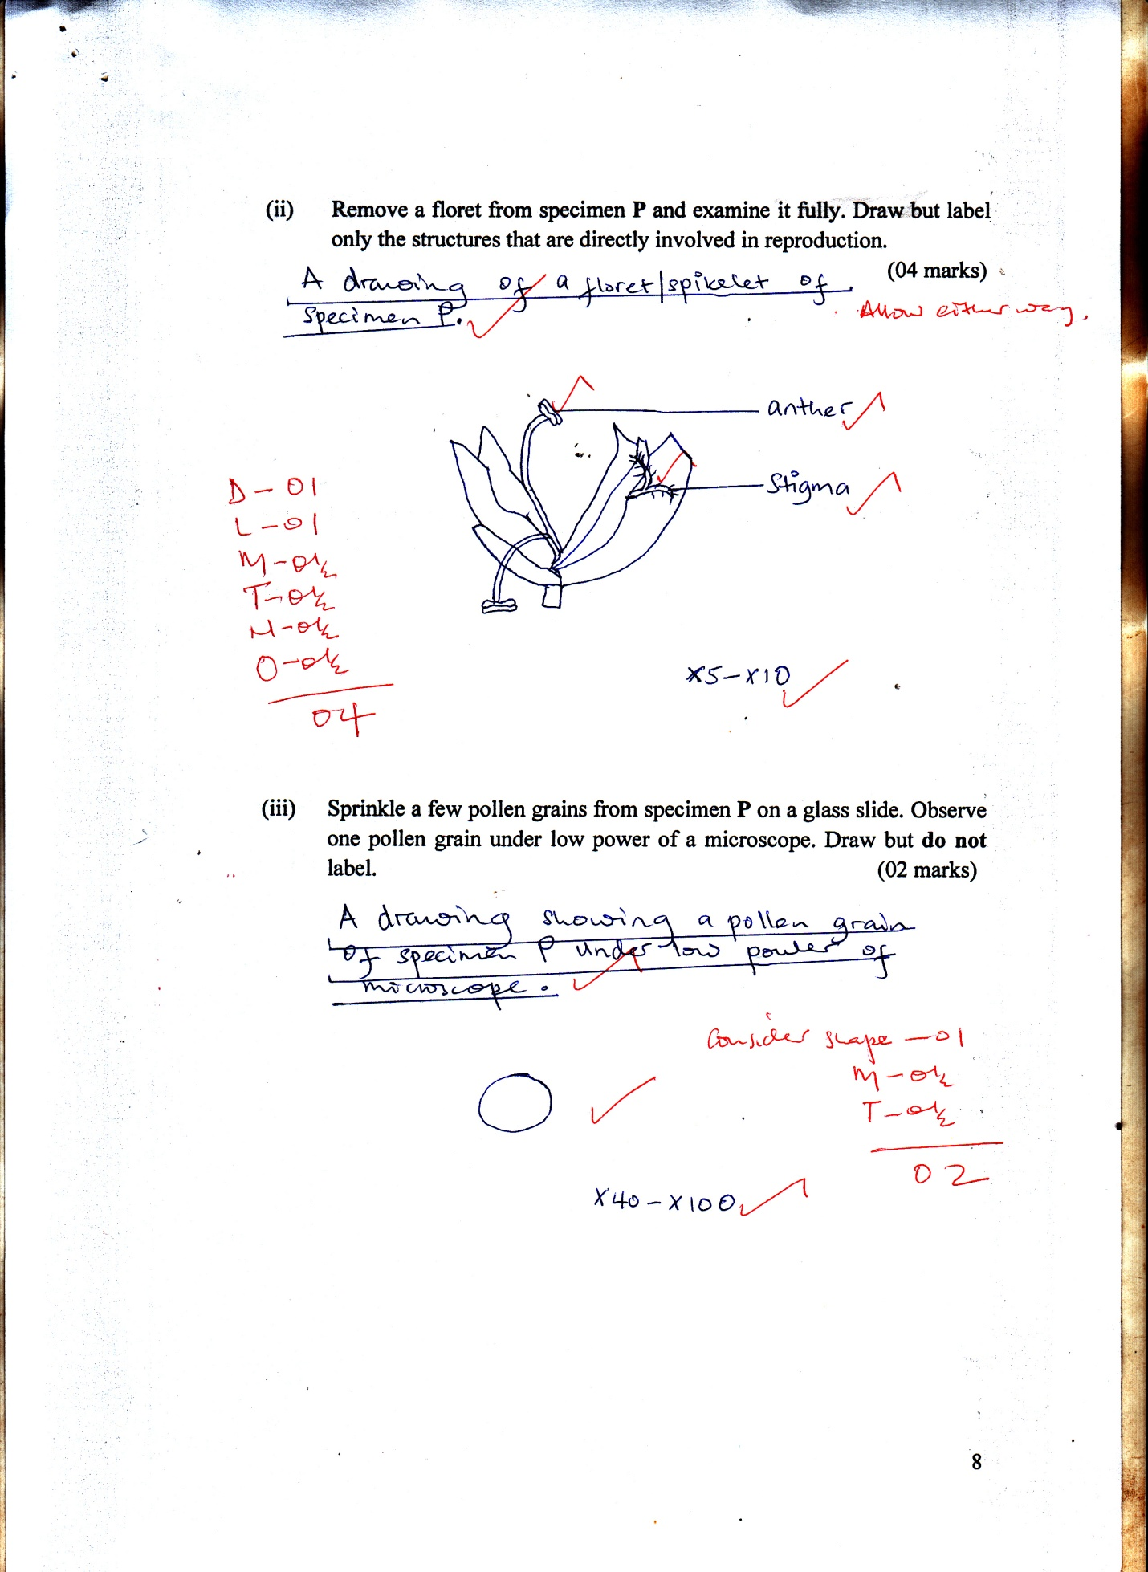

*Round shape;*

*Or circular shape;*

*Rej; Other shapes;*

1. (i) Remove the gynoecium of the floret of specimen **R** and examine it

fully. Draw and label. (04 marks)

*A drawing showing the gynoecium of a floret of specimen* ***R****.*

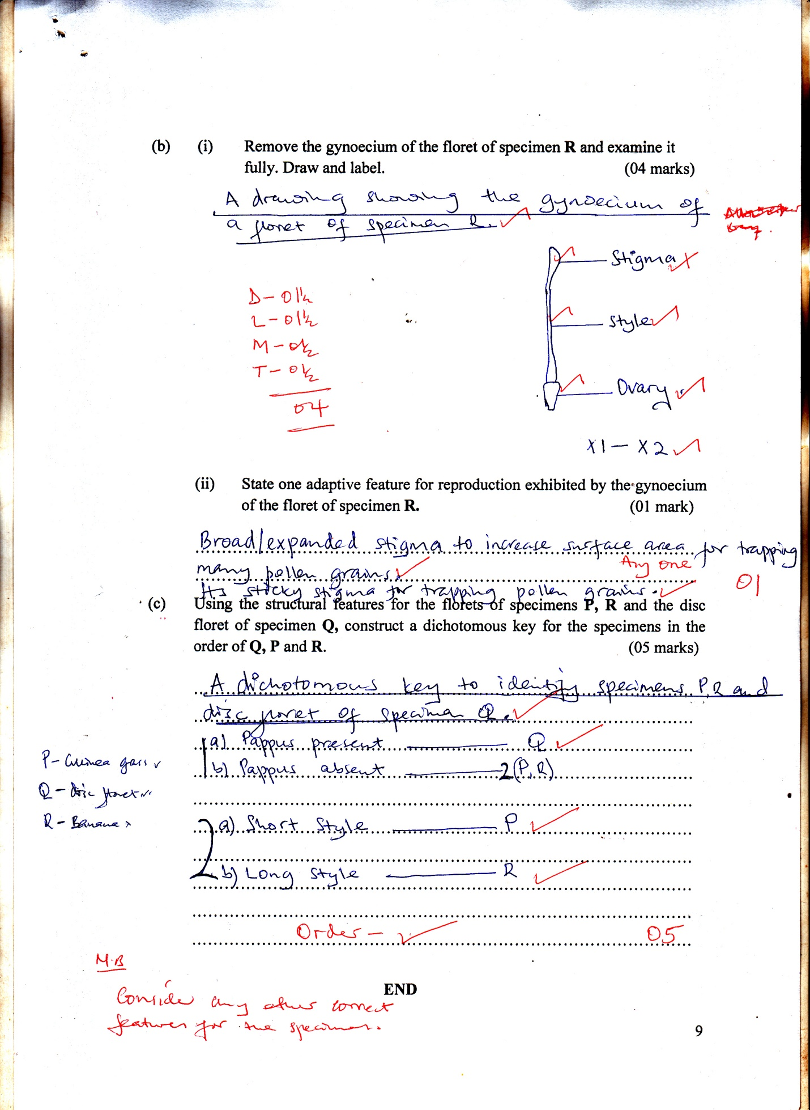

*D - 01 ½*

*L – 01 ½*

*M – 0 ½*

*T – 0 ½*

*= 04 marks*

(ii) State one adaptive feature for reproduction exhibited by the gynoecium of the floret of specimen **R.** (01 mark)

*Broad / expanded stigma to increase surface area for trapping many pollen grains****;*** *(any 1)*

*Sticky stigma far trapping pollen grains****;***

1. Using the structural features for the florets of specimens **P, R** and the disc floret of specimen **Q,** construct a dichotomous key for the specimens in the order of **Q, P** and **R**. (05 marks)

***A dichotomous key to identify specimens P, R and disc floret of specimen Q***

*P = guinea grass / Q – disc – floret bidens pilosa / R – banana*

$$1_{b) Pappus absent ……………………………………….2 (P, R)}^{a) Pappus present ……………………………………….Q}$$

$$2_{b) Long style…………………………….…………...R; }^{a) short style ……………………………….………..P; }$$

*Order - 01*

*NB: Consider any other correct*

*Features for the specimen*

**OR**

$$1_{b) Inferior ovary ……………………………………….Q }^{a) Superior ovary ……………………………………….2}$$

$$2_{b) Assesile floret…………………………….…………...P; }^{a) Sessile floret ……………………………….………..R; }$$

**END**